**Business Scenario: A company with different employees of different age groups having different salary and are working in different departments.**

let's break down the scenario into entities, relationships, attributes, and cardinalities:

Entities:

1. Employee

2. Department

Attributes:

1. Employee:

- EmployeeID (Primary Key)

- Name

- Age

- Salary

- DepartmentID (Foreign Key referencing Department)

2. Department:

- DepartmentID (Primary Key)

- Name

Relationships:

1. Works_in:

- An employee works in a department.

Now, let's add cardinalities to the relationships:

- Each employee works in one department.

- Each department can have multiple employees.

With this information, we can now create the ER diagram:

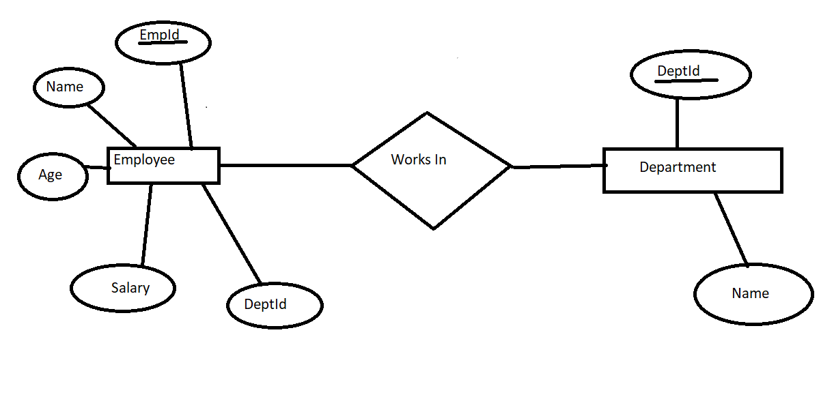

This ER diagram is normalized up to the third normal form, as there are no repeating groups and all attributes are dependent on the primary key. Each entity represents a distinct concept, and there are appropriate relationships between entities.